Lesson 2
Quadratic Equations

sPECIFIC OBJECTIVES:

At the end of the lesson, the student is expected to be able to :

- solve quadratic equations using different methods,
- describe the number and type of roots in a quadratic equation base on discriminant,
- solve equations in quadratic form,
- solve application problems.

2.1 Quadratic Equation

Definition 2.1.1 Quadratic Equation

A quadratic equation in x is a second-degree equation that can be written in the standard form ax+ bx + c = 0, where a, b, and c are real constants and a ≠ 0.

Example 2.1.1 The following are quadratic equations:

- 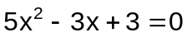
- 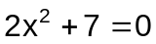
- 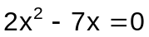

2.2 Solving Quadratic Equations

There are four algebraic methods of solving quadratic equation in one variable, namely:

- solution by factoring
- solution by extraction of roots
- solution by completing the square
- solution by quadratic formula

2.2.1 Solving Quadratic Equations by Factoring

In solving quadratic equations by factoring, use the following steps:
- Write the equation in standard form ax+ bx + c = 0.
- Factor the left side completely.
- Apply the Zero Factor Property to find the solution set.

Definition 2.2.1 Zero Factor Property

The Zero Factor Property states that if the product of two or more factors equals zero, then at least one of the factors equals zero. Therefore if a and b are factors such that ab = 0, then a = 0 or b = 0.

Example 2.2.1 Find the solution set of each of the following quadratic
equations.

a) 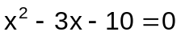 ans. {-2,5}
b) 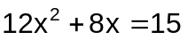 ans. 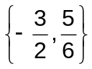
c) 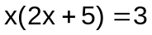 ans. 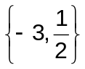
d) 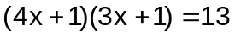 ans. 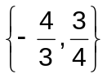
e) 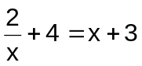 ans. {-1,2}

2.2.2 Solving Quadratic Equation by Extraction of Roots

In solving quadratic equation by extraction of roots, consider the following
principles.

- if k > 0 is a real number, the equation 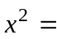k has solutions 2 distinct real solutions; 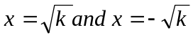
- if k = 0, the equation 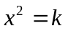 has a double root of zero.
- if k < 0, the equation has exactly two imaginary solutions.

Example 2.2.2 Find then solution set of the following equations:

- 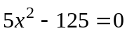 ans. {-5,5}
- 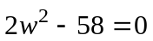 ans. 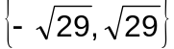
- 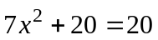 ans. {0}
- 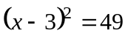 ans. {-4,10}
- 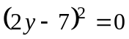 ans. 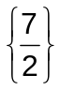

2.2.3 Solving Quadratic Equation by Completing the Square

In solving quadratic equation by completing the square, the following must be followed:

- Write the equation in ax² +bx = c form.
- Divide both sides of the equation by the coefficient of 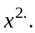
- Take one-half of the coefficient of x, square this number, and add the result to both sides of the equation.
- Write the left side of the equation as a perfect square.
- Apply the Square Root Property.
- Solve the resulting linear equations for the variable

Remark:

The Square Root Property states that if m and n are real numbers and 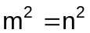, then m = n or m = -n.

Example 2.2.3 Solve the following by completing the square:

a) 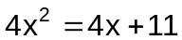 ans. 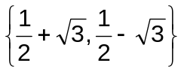
b) 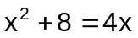 ans. {2+2i, 2-2i}

c) 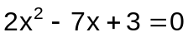 ans. 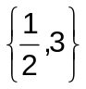
d) 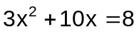 ans. 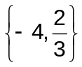

2.2.4 Solving Quadratic Equation by Quadratic Formula

Definition 2.2.2 The Quadratic Formula
The roots of the quadratic equation ax² + bx + c = 0, where a, b, and c are constants and a ≠ 0 are given by:
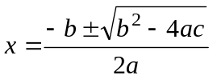

Example 2.2.4 Solve the following quadratic equations using the quadratic
formula.

a) 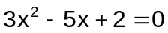 ans. 1 and 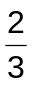
b) 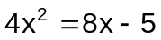 ans. ½(2+i) and ½(2-i)

2.3 Discriminant of a Quadratic Equation

Definition 2.3.1 Discriminant
Let a, b, and c be real numbers such that a ≠ 0. The discriminant of the quadratic equation ax² + bx + c = 0 is given by 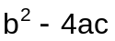 and can be used to classify the solutions of the equations as follows:
1. a perfect square Two distinct rational solutions
2. a positive non-perfect square Two distinct irrational solutions
3. = 0 One repeated rational solution
4. a negative number Two distinct imaginary solutions

Example 2.3.1 Determine the nature of solutions of the following quadratic
equations:

- x² + 4x – 5 = 0
- x² + 2x + 5 = 0
- 4x² +12x +9 = 0
- 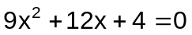
- 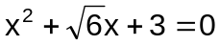

2.4 Equations in Quadratic Form
In solving equations in quadratic form, use the following steps:
- Rewrite the equation in quadratic form using a substitute variable.
- Solve the resulting quadratic equation for the substitute variable.
- Replace the substitute variable with the original variable and solve.
- Check your answer in the original equation.

Example 2.4.1 Find the solution set of the following equations:

a) 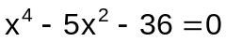 ans. {-3,3,-2i,2i}
b) 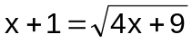 ans. {4}
c) 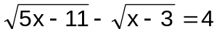 ans. {12}
d) 2x -9 + 4 = 0 ans. 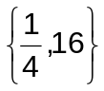
e) 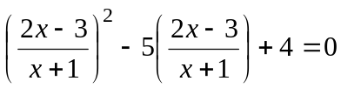 ans. 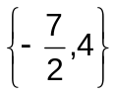

Exercise 2.4.1 Find the solution set of each of the following quadratic equations.

1. 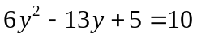
2. 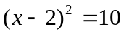
3. 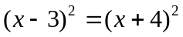
4. 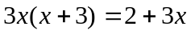
5. 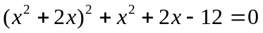
6. 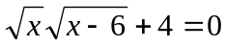
7. 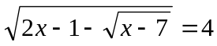
8. 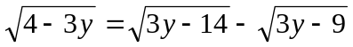
9. 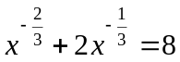
10. 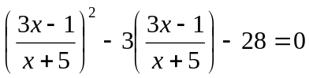

  - Applications of Second-degree Equation in One Variable

Example 2.5.1 Solve the following problems:

a) The product of two consecutive positive integers is 56. Find the lowest integer. ans. 7

b) Paul can finish a job in 2 hrs less than John. Working together they can finish it in 2 hours and 24 minutes. How long would it take Paul to finish the job working alone? ans. 4 hours
- The length of a rectangle is five more than twice its width. The area of the rectangle is 52 sqm. Find the dimensions of the rectangle.
ans. 4 and 13

- A tank can be filled in 2 hours by 2 pipes together. The larger pipe can fill it in 3 hours less than the smaller. How long will it take each pipe to fill the tank?
ans. 6 and 3

- A car traveled the first 100 kilometers of a trip at one speed and the last 135 kilometers at an average of 5 kilometers per hour less. If the entire trip took 5 hours, what was the average speed of the car for the first part of the trip?
ans. 50 kph

Exercise 2.5.1 Solve each of the following problems.

- Find a number whose square exceeds 14 times the number by 51.
- The denominator of a fraction is 1 more than the numerator. When 5/6 is added to the fraction, the terms of the fraction are reversed. What is the original fraction?
- A boy can row 16 kilometers downstream and return a distance of 16 kilometers upstream in 5 hours. If the rate of the current is 6 km/hr, what is the boy’s rate of rowing in still water?
- A box is to be formed from a rectangular piece of wood by cutting equal squares of 10 inches on a side and then folding the sides. The piece of wood is thrice as long as it is wide. If the volume of the box is 7680 in³, What are the dimensions of the original piece of wood?
- The science club bought a Php 2400 worth of apparatus for their experiment. If there had been 8 more students in the club, then the cost per member to buy the apparatus would have been Php 10 less. How many students are in the club?

